
Name : Ch Mubashir.
SAP : 56892.
Course : Data Visualization (BS-DS-6-1).
Instructor : Uzair Rasheed.
Date : 2-16-2026

**LAB TASK 03**

Insight Questions & Reporting Tasks:

Contents
Table of Contents 3
Task 1 3
Excel Steps : 3
Screenshot : 3
Insight 1: Overall Survival Rate : 3
Task 2 4
Excel Steps : 4
Screenshot: 4
Insight 2: Impact of Gender on Survival : 4
Task 3 5
Excel Steps : 5
Screenshot : 5
Insight 3: Passenger Class Influence 5
Task 4 6
Excel steps : 6
Screenshots : 6
Insights 4 Age Group Survival : 7
Task 5 Fare vs Survival Relationship 7
Excel Steps : 7
Screenshot : 7
Insights 5 Fare vs Survival Relationship : 7
Task 6 Most Common Embarkation Port 8
Excel Steps : 8
Screenshot : 8
Insights Fare vs Survival Relationship 8
Task 7 Average Fare by Class 9
Excel Steps : 9
Screenshot : 9
Insights Average Fare by Class 9
Task 8 Children vs Adults Survival 10
Excel Steps : 10
Screenshots : 10
Insights : 11
Task 9 Which Gender Paid Higher Fare? 11
Excel Steps : 11
Screenshots : 11
Insights : 12
Task 10 Top 5 Highest Fares 12
Excel Steps 12
Screenshot : 12
Insights : 13
Task 11 Age Distribution 13
Excel Steps : 13
Screenshots : 14
Insights : 14
Task 12 Family Size Effect 14
Excel Steps 14
Screenshot : 15
Insights : 15
Conclusion : 15

Table of Contents

Task 1

Excel Steps :
- Select Table → Insert → PivotTable
- Drag:
  - Survived → Rows
  - Survived → Values (Count)
- Right-click values → Show Values As → % of Grand Total
- Insert → Pie Chart.

Screenshot :
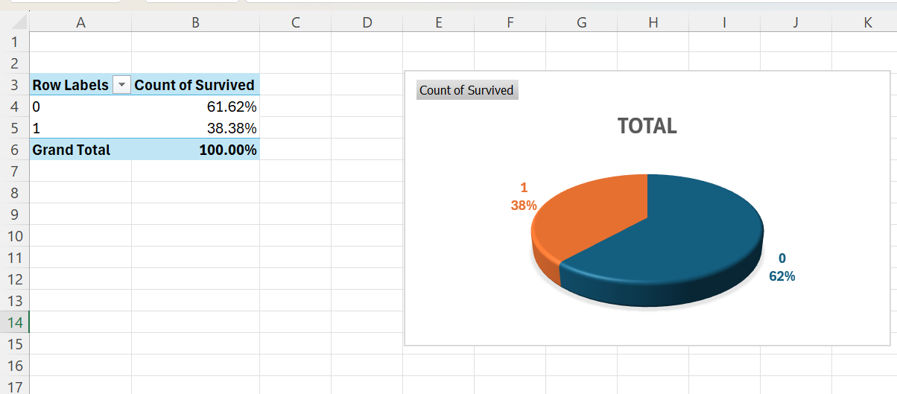

Insight 1: Overall Survival Rate :
- Numerical Evidence:
Pivot table shows percentage of survived vs not survived passengers.
- Explanation:
The majority of passengers did not survive the disaster, while only a smaller proportion managed to escape safely. This indicates that survival was limited due to insufficient lifeboats and emergency preparedness.
- Significance:
This provides a baseline understanding that survival was rare and influenced by specific factors explored in later analysis.

Task 2

Excel Steps :
1. Insert PivotTable.
2. Drag:
- Sex → Rows
- Survived → Columns
- Survived → Values (Count)
3. Insert → Clustered Bar Chart.

Screenshot:
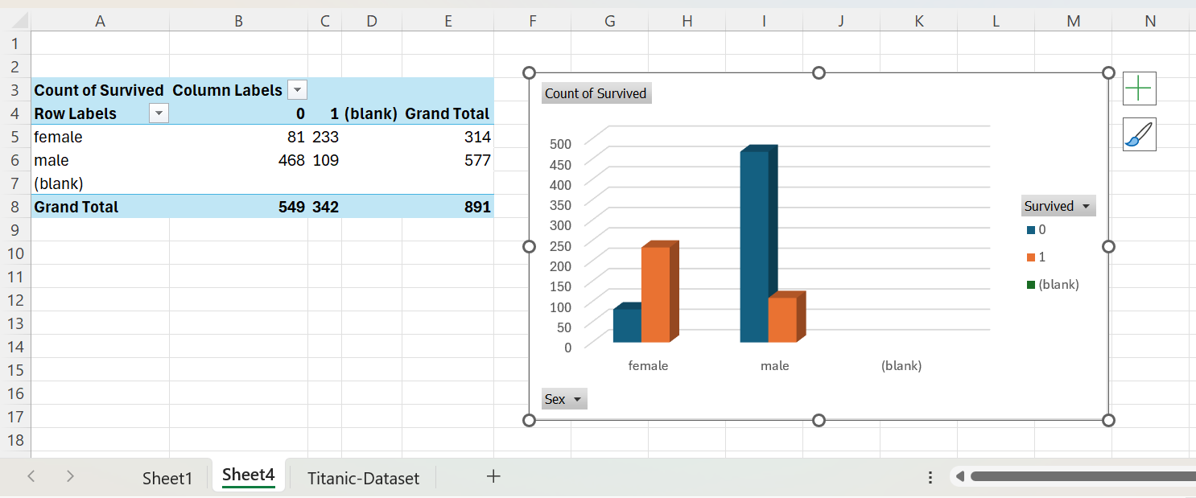

Insight 2: Impact of Gender on Survival :
- Explanation:
Female passengers had a significantly higher survival rate compared to males. This reflects the historical evacuation policy of prioritizing women during rescue operations.
- Significance:
Gender was one of the strongest determinants of survival, showing social norms influenced emergency decisions.

Task 3

Excel Steps :
- Pivot:
- Pclass → Rows
- Survived → Columns
- Count → Values
- Insert → Column Chart.

Screenshot :
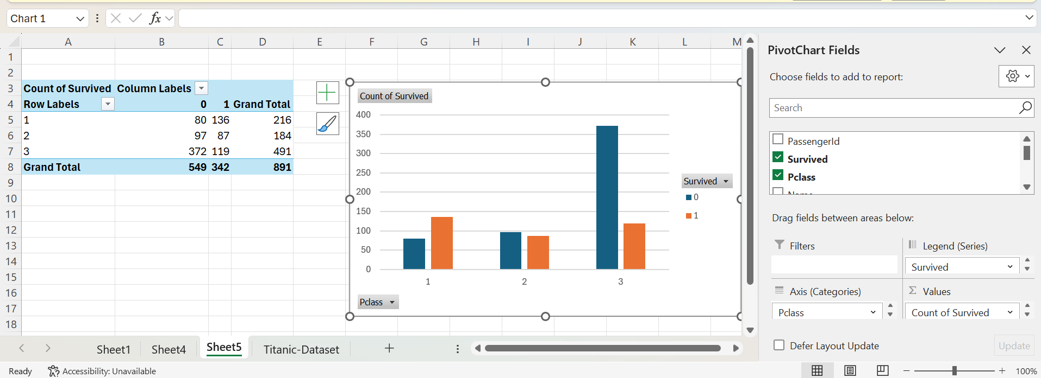

Insight 3: Passenger Class Influence
Explanation:
First-class passengers experienced the highest survival rates, while third-class passengers had the lowest. This suggests wealthier passengers had better access to lifeboats and safer cabin locations.
Significance:
Socioeconomic inequality directly affected survival chances.

Task 4

Excel steps :
(Create Age Groups)
- Add new column named AgeGroup
- Enter formula:
=IF([@Age]<18,"Child",IF([@Age]<40,"Adult","Senior"))
- Now Pivot:
- AgeGroup → Rows
- Survived → Columns
- Count → Values
- Insert Bar Chart.

Screenshots :
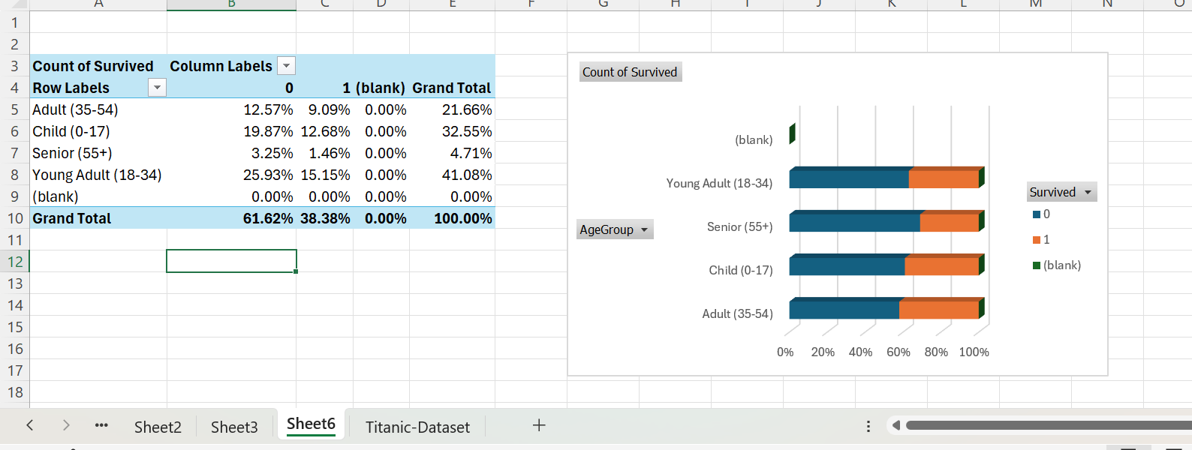

Insights 4 Age Group Survival :
- Explanation :
Children show better survival proportions compared to adults and seniors, indicating prioritization of younger passengers.
- Significance:
Age-based rescue behavior existed.

Task 5 Fare vs Survival Relationship

Excel Steps :
  - Select Fare column.
  - Hold Ctrl → Select Survived column.
  - Insert → Scatter Plot

Screenshot :
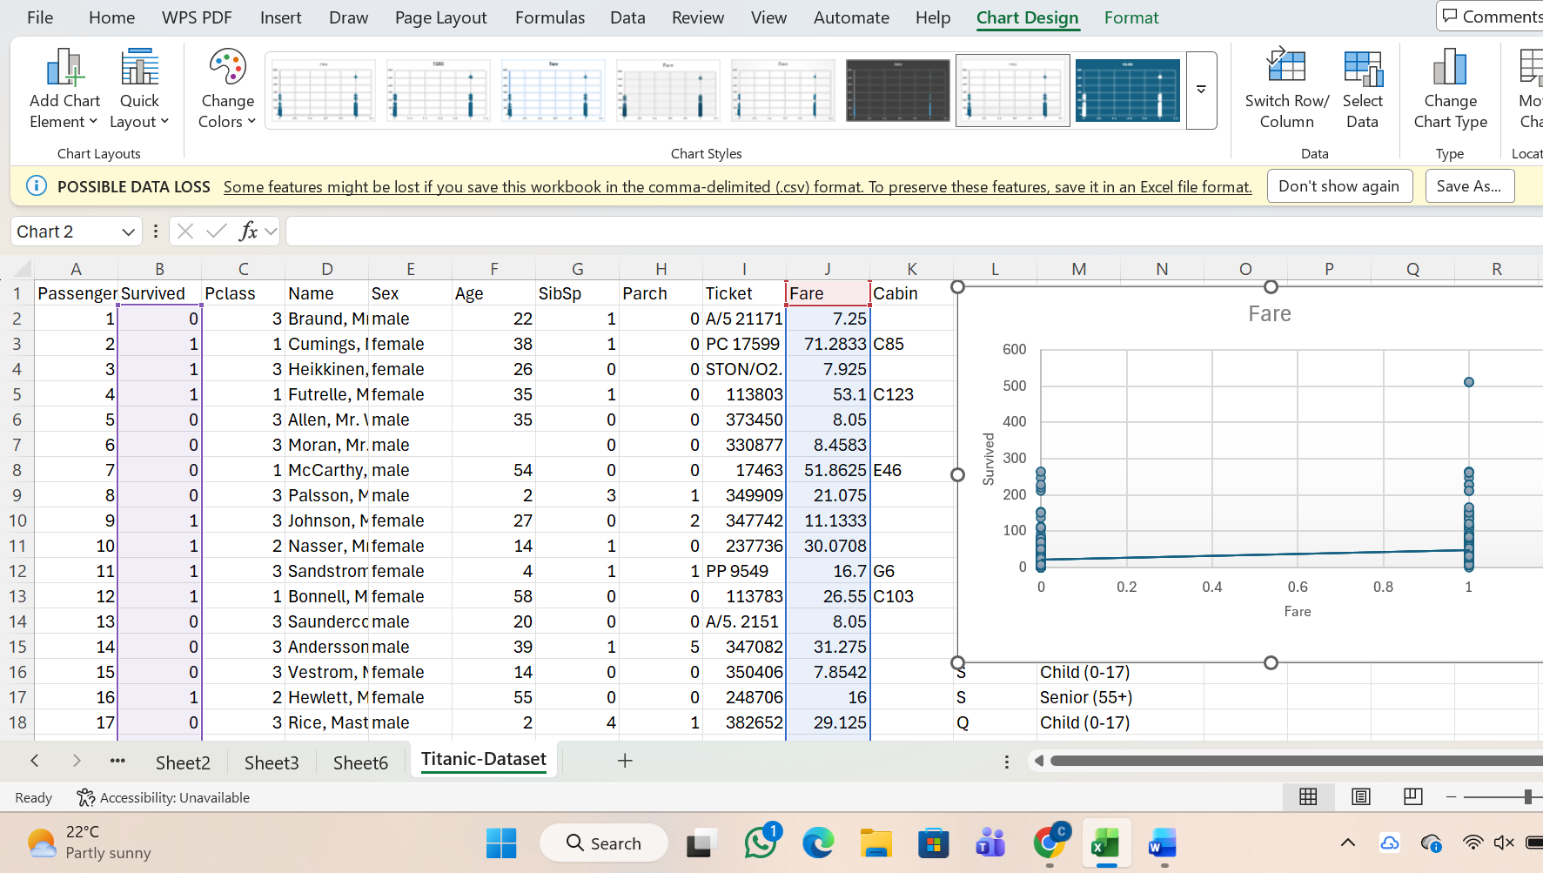

Insights 5 Fare vs Survival Relationship :
- Explanation:
Passengers paying higher fares appear more frequently among survivors, suggesting a link between wealth and safety.
- Significance:
Ticket fare indirectly reflects class privilege and access to rescue resources.

Task 6 Most Common Embarkation Port

Excel Steps :
Excel Steps
  - Pivot:
- Embarked → Rows
- Count → Values
  - Insert Pie Chart.

Screenshot :
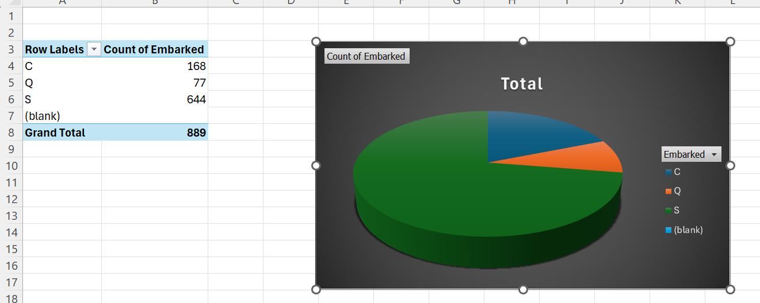

Insights Fare vs Survival Relationship
- Explanation
- Most passengers boarded from Southampton, making it the primary embarkation location.
- Significance:
This explains passenger distribution across the dataset.

Task 7 Average Fare by Class

Excel Steps :
1. Pivot:
- Pclass → Rows
- Fare → Values → Change to Average
2. Insert Pivot Chart.

Screenshot :
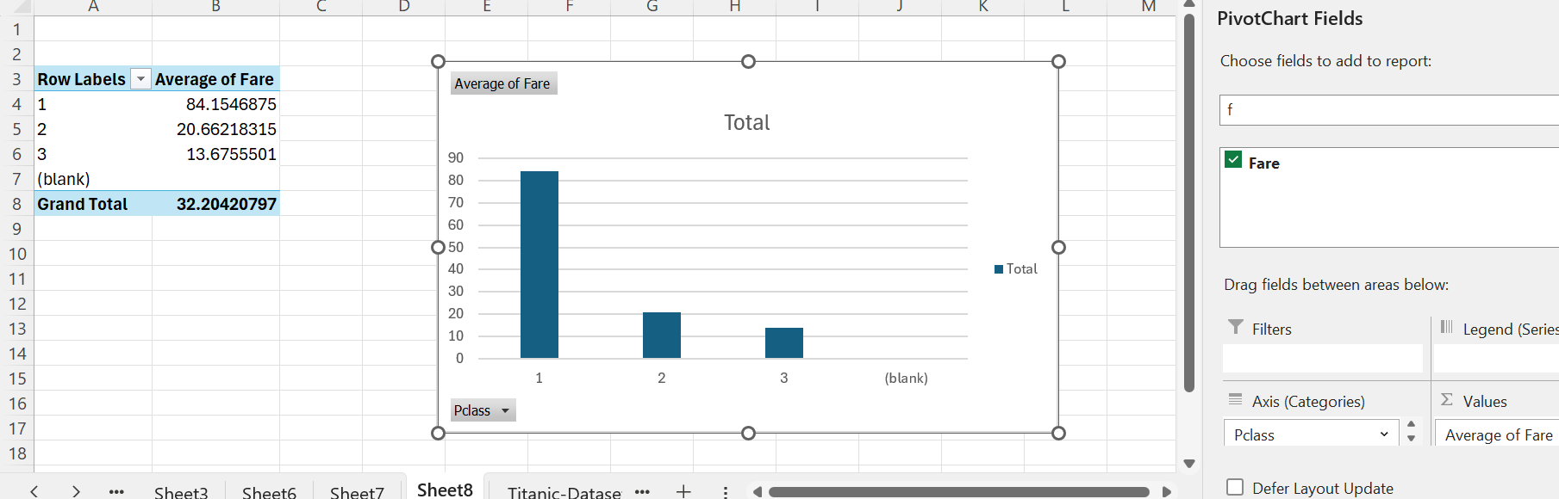

Insights Average Fare by Class
- Explanation
Average fare rises dramatically from third to first class, showing strong economic division among passengers.
- Significance:
Class differences were financially significant.

Task 8 Children vs Adults Survival

Excel Steps :
1. Create column:
=IF([@Age]<18,"Child","Adult")
2. Pivot using this column + Survived.
3. Insert Column Chart.

Screenshots :
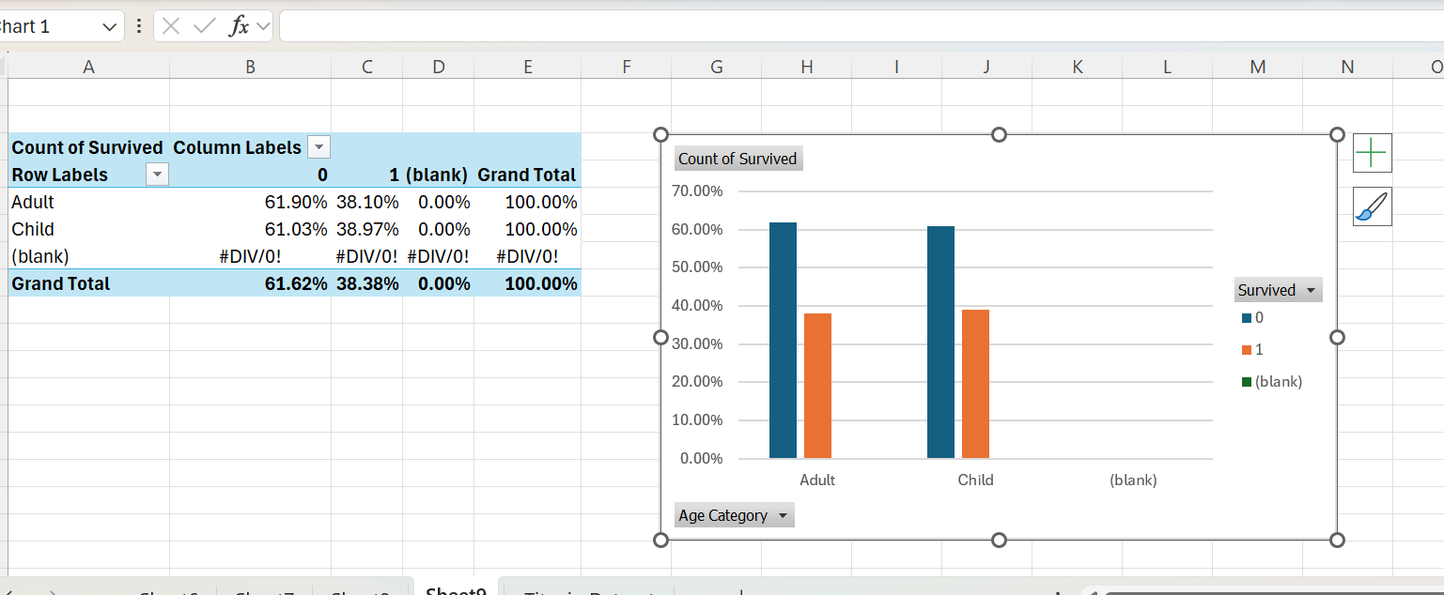

Insights :
- Explanation
Children had better survival rates than adults, supporting evacuation prioritization policies.
- Significance:
Vulnerability influenced rescue.

Task 9 Which Gender Paid Higher Fare?

Excel Steps :
Pivot:
- Sex → Rows
- Fare → Values → Average
Insert Bar Chart.

Screenshots :
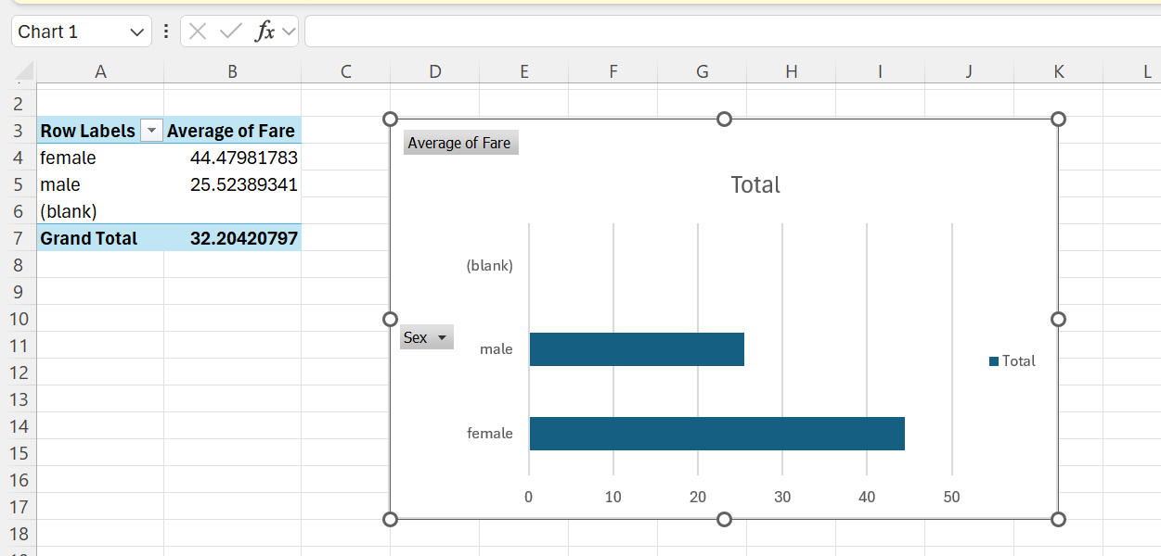

Insights :
- Explanation
Male passengers paid slightly higher fares on average due to higher presence in premium travel classes.
- Significance:
Gender distribution varied across classes.

Task 10 Top 5 Highest Fares

Excel Steps
- Select Fare column.
- Home → Sort Largest to Smallest
- Take top 5 values.
- Insert Column Chart.

Screenshot :
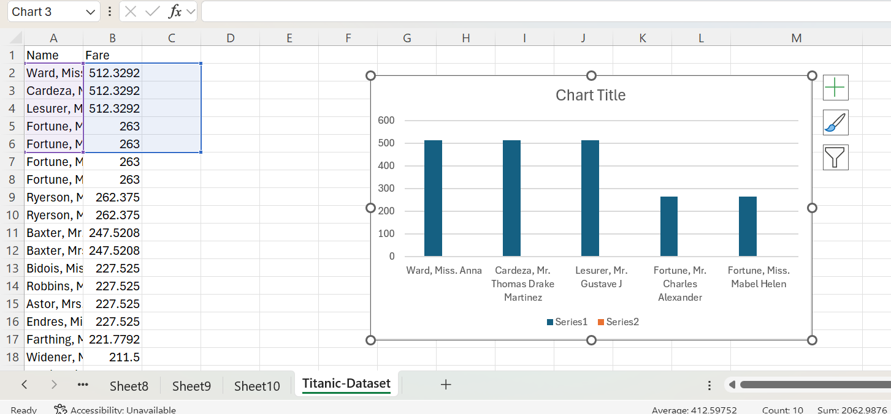

Insights :
- Explanation
Top fares are extremely higher than the majority, indicating luxury accommodations for elite travelers.
- Significance:
The ship served both wealthy elites and lower-income passengers.

Task 11 Age Distribution

Excel Steps :
Select Age column → Insert → Histogram.

Screenshots :
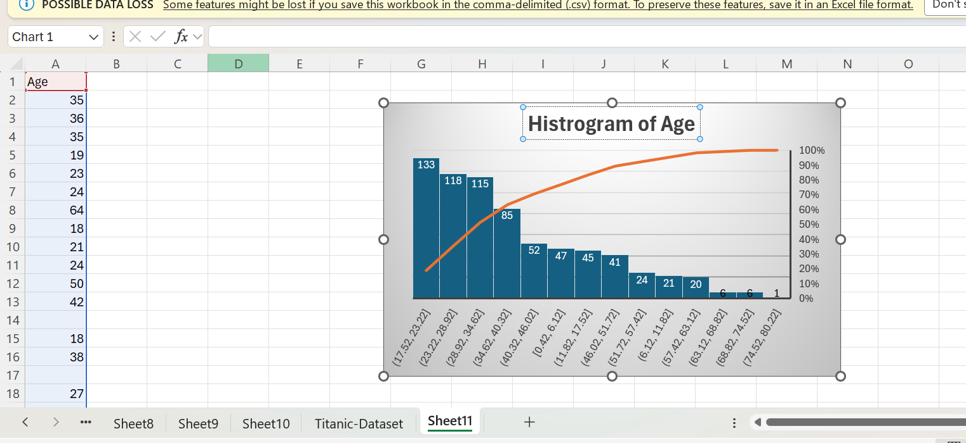

Insights :
- Explanation
Most passengers were young adults, suggesting working-age individuals dominated travel.
- Significance:
Demographics influence survival and family patterns.

Task 12 Family Size Effect

Excel Steps
Create column FamilySize:
=[@SibSp]+[@Parch]
Pivot:
- FamilySize → Rows
- Survived → Values
Insert Bar Chart.

Screenshot :
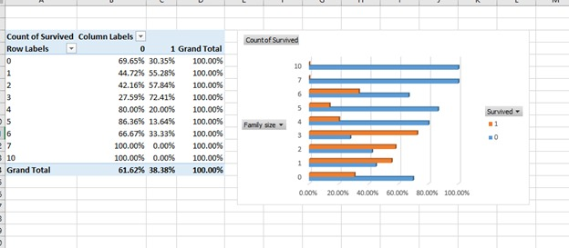

Insights :
- Explanation
Passengers traveling in small families survived more often than those in very large families, likely due to easier mobility during evacuation.
- Significance:
Group size affects emergency response outcomes.

Conclusion :
This analysis shows that survival on the Titanic was strongly influenced by structured social factors such as gender, passenger class, age, and economic status. Data visualization techniques in Excel helped transform raw historical data into meaningful insights, demonstrating how analytical tools can uncover patterns that explain real-world events.

